Name: TextToSpeech

Description: This extension reads the selected text which we can hear through speaker output of our system.

Image:

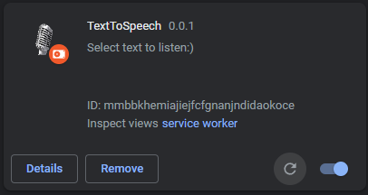

Installation guide:

1. Go to Chrome Settings using three dots on the top right corner.
2. Then Select Extensions.
3. Now, Enable developer mode
4. Click on Load Unpacked and select your Unzip folder which contains your manifest file.
5. The extension will be installed now

Video:

